OCA Self Care Pack
2022

The focus of this booklet is to provide tips on how to stay safe, self-help ideas, support websites and helplines. Please also use the school website https://ormistonchadwickacademy.co.uk/key-info/safeguarding for advice on how to seek help and also how to report online issues.

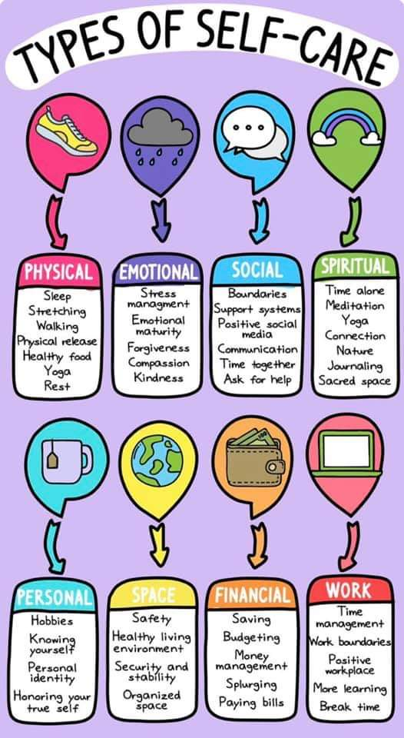
What is in our control

Sometimes self-care can be difficult, especially in uncertain times. One way to manage this is to think about what is within our control and what is not. We are all unique so this can be different for us all, however some of these are similar.
The image below shows examples of things we can control and things we can not control. At times we focus more on what we cannot control and this can lead to negative emotions. Try to think about what you can let go of that is not in your control.
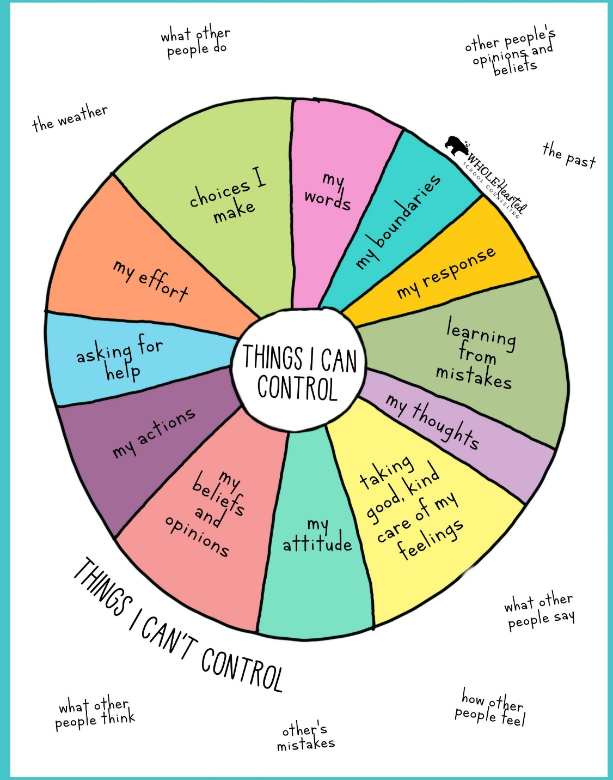

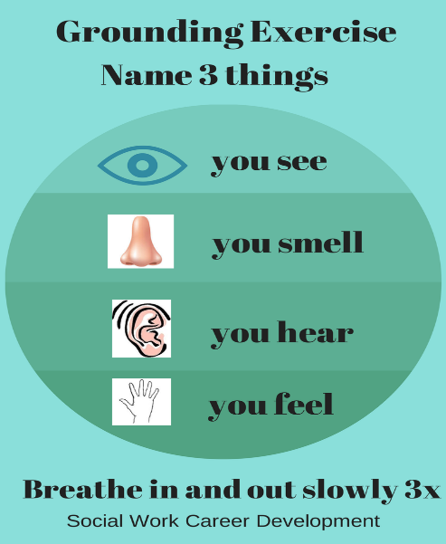
Mindfulness
This is a technique to help us focus on the here and now, rather than worrying about the past or the future. It is a non-judgemental approach that can help bring our awareness to our thoughts feelings and senses. Some benefits of mindfulness are reducing stress, helping manage emotions and improved concentration.
Try the exercise in the image:

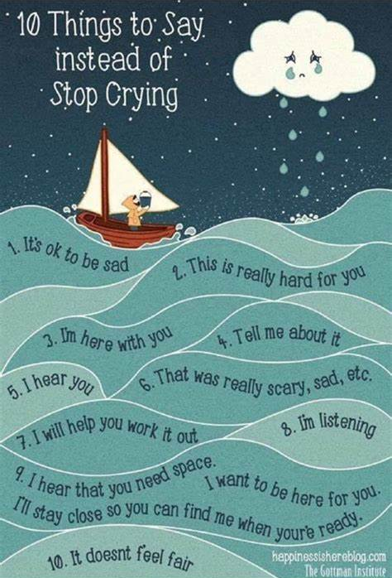

How we can support each other
Always make sure you are there for each other and remember that there are always people you can reach out to for support. When helping each other it can be difficult to know what to say when someone is upset. This image will give you some ideas as to what you can say and do.

Identify who is in your support network; this could include, pets, friends, school staff, family or carers, GP, NCPCC or Kooth; reach out to them if you need support.

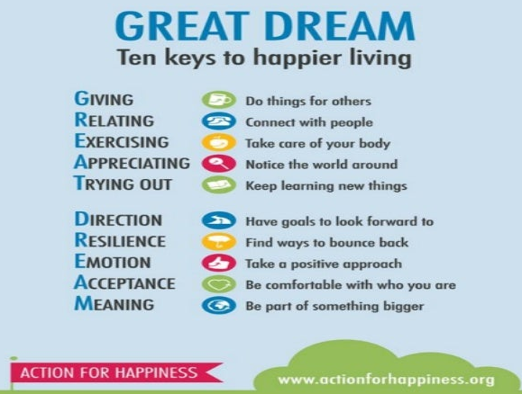
Types of self-care
The image to the right shows ten ways in which we can look after our well-being. Other examples include:
- listening to music
- drawing, reading
- reducing social media use
- exercising
- journaling,
- baking or cooking
- hobbies and interests
- expressing emotions
- learn a new skill,
- socialising
- goal setting.
The following website has over 90 self-care strategies https://www.annafreud.org/selfcare/

My Self Care Plan
Try and make your own self care plan, based on the four different types of self-care. This can include activities on your own, with family or with friends.
Emotional ____________________________________________________________
Physical ____________________________________________________________

Spirtual ____________________________________________________________
Social ____________________________________________________________

If you are struggling:
If you are suffering from low mood or have had thoughts about feeling like you want to hurt yourself, try to understand and identify what may be causing you to feel like this. Try some of these coping strategies:
- Speak to family members
- Scribbling with red ink
- Listening to music or writing music
- Writing down your feelings and them rip the paper up
- Take a bath hot/cold shower
- Call a friend for distraction
- Punch a cushion
- Squeeze a stress ball
- Exercise – go for a walk or bike ride
- Write a list of your achievements
- Reason with yourself

Helplines for support over the summer
If you or someone you know needs help please talk to a parent / carer or trusted adult such as GP. In a real emergency please call 999 or go to A&E. There are also the following agencies

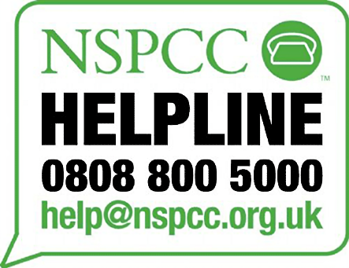
Information can also be found on the safeguarding page of the school website.
My Safety Plan
What makes you feel upset?
How can I keep myself safe right now?
What helps me feel good?

If I need help, who can I call

My Emergency safety plan
I will phone the police if I am afraid that I might or someone else might get hurt or is hurt.
Police call 999
Children services Halton – 01519078305 out of hours or weekend 03450500148
Children service Liverpool – 01512333700
If I have a social worker (Halton) – 03033334300 or out of hours 03450500148
Childline 08001111
CAMHS 01928568162
General safety tips
